ML Project Report: Patient Recovery Prediction (Checkpoint 1)

Team: Teen Bhai Teeno Tabahi
- Yash Gupta (IMT2023125)
- Pranay Kelotra (IMT2023563)
- Hitanshu Seth (IMT2023100)

Github Link: https://github.com/YashGupta2106/ML_Project_Patient_Recovery.git

1. Task

The objective of this project is to develop and evaluate predictive models capable of estimating a patient's recovery progress. The goal is to predict a numerical "Recovery Index" based on a set of treatment, medical, and lifestyle factors. This constitutes a regression task, where the model learns the relationship between the input features and the continuous target variable.

2. Dataset and Features Description
The dataset comprises 10,000 synthetic patient records. Each record contains five predictor variables related to medical and lifestyle factors, along with a single target variable, the "Recovery Index."

Features (Predictors):
- Therapy Hours: The total number of hours a patient spent in therapy sessions (Numerical).
- Initial Health Score: The patient’s health assessment score recorded during their first check-up (Numerical).
- Lifestyle Activities: Whether the patient engaged in additional healthy lifestyle activities (Categorical: "Yes" or "No").
- Average Sleep Hours: The average number of hours the patient slept per day (Numerical).
- Follow-Up Sessions: The number of follow-up sessions the patient attended (Numerical).

Target Variable:
- Recovery Index: A numerical measure of the overall recovery progress for each patient, with a score ranging from 10 to 100 (Numerical).

3. Exploratory Data Analysis and Preprocessing
The following section outlines the systematic steps taken to clean, explore, and prepare the dataset for model training. This process is crucial for understanding data characteristics, identifying potential issues, and ensuring models are trained on valid, well-structured data.

3.1. Initial Data Inspection
- Libraries and Data Loading: Essential libraries (Pandas, NumPy, Matplotlib, Seaborn, Scikit-learn) were imported. The dataset was loaded into a Pandas DataFrame.
- Data Overview: The first few rows were examined using df.head() to understand the data's structure.
- Data Types and Integrity: Column data types were verified. df.info() and df.describe() were used to get a statistical summary of numerical columns (mean, median, standard deviations) and identify any immediate anomalies.

3.2. Handling Missing and Duplicate Values
- Missing Values: The dataset was thoroughly examined for any null or missing values. No missing data was found, so no imputation was necessary.
- Duplicate Values: The dataset was checked for duplicate patient records (e.g., based on a unique ID or identical rows). No duplicate entries were found.

3.3. Exploratory Data Analysis (EDA)
- Visual analysis was performed to understand feature distributions and their relationships.
- Distribution of Features (Histograms): Histograms were plotted for all numerical features — Therapy Hours, Initial Health Score, Average Sleep Hours, Follow-Up Sessions — and the target variable Recovery Index. The analysis showed that Therapy Hours and Follow-Up Sessions had a slight right skew, indicating that most patients underwent a moderate number of sessions, with a few receiving significantly more. The Recovery Index appeared approximately normally distributed, which is favorable for regression-based modeling.
- Outlier Detection (Boxplots): Boxplots were generated for each numerical feature to visually identify potential outliers. A few mild outliers were seen in Therapy Hours and Average Sleep Hours, but they were within reasonable clinical ranges and retained to preserve natural data variability and model generalization.
- Correlation Analysis (Heatmap): A correlation matrix and corresponding heatmap were plotted to examine linear relationships between numerical features (after encoding Lifestyle Activities). Key observations from the correlation matrix:
- Strong Positive Correlation: Initial Health Score exhibited a very strong positive correlation (≈ 0.91) with Recovery Index. This suggests that patients starting with better initial health tended to show higher recovery scores — an expected clinical trend.
- Moderate Correlation: Therapy Hours showed a moderate positive correlation (≈ 0.38) with Recovery Index, implying that increased therapy engagement moderately improves recovery outcomes.
- Negligible or No Correlation: Lifestyle Activities, Average Sleep Hours, and Follow-Up Sessions had very weak correlations (close to 0) with the target variable, suggesting limited direct linear influence.
- Low Multicollinearity: The predictors displayed very low inter-correlations among themselves, reducing concerns of multicollinearity in linear regression or similar models.
- Overall Insight: The EDA suggests that Initial Health Score is the most influential predictor of Recovery Index, followed by Therapy Hours. Other behavioral and lifestyle factors may still contribute through non-linear or interaction effects, which can be explored during model development.

3.4. Data Preprocessing
The following steps were taken to prepare the data for modeling:
- Removing ID Column: Any non-predictive columns, such as a patient ID, were removed as they provide no value for model training.
- Encoding Categorical Features: The Lifestyle Activities column, with "Yes" / "No" entries, was converted into numerical format (1 for "Yes", 0 for "No") to be used in the models.
- Standardizing Numerical Features: All numerical features were standardized using StandardScaler from Scikit-learn. This process scales the features to have a mean of 0 and a standard deviation of 1, ensuring that features with larger scales (like Initial Health Score) do not disproportionately influence models that are sensitive to feature scale (e.g., Ridge, Lasso, kNN).

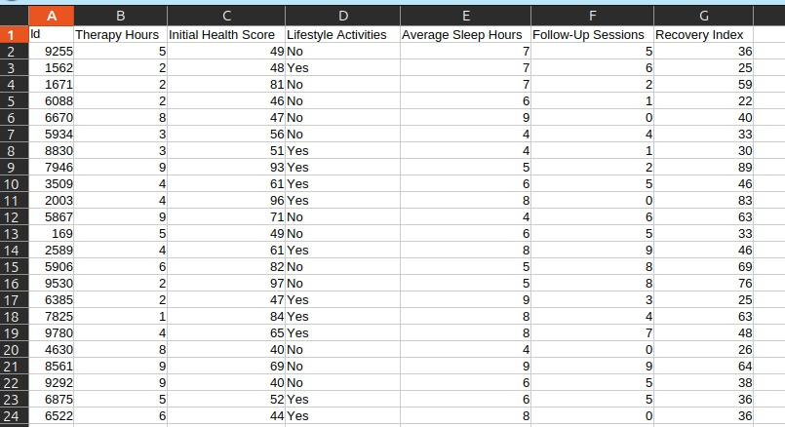
Before Preprocessing
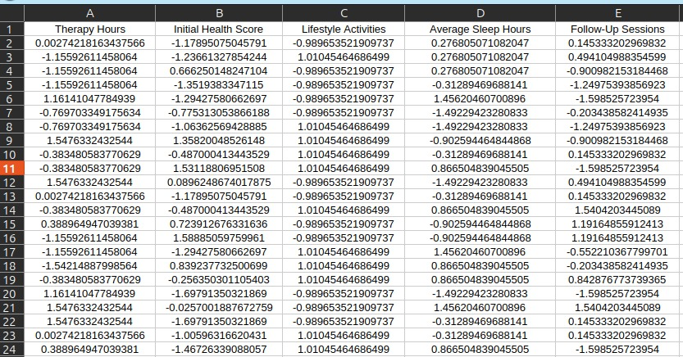
After preprocessing

3.5. Splitting the Dataset
The fully preprocessed dataset was split into training (80%) and testing (20%) sets. This ensures that the model's performance can be evaluated on unseen data, providing a more accurate measure of its generalization capabilities.
(All preprocessing and analysis steps are available at: [EDA_and_Preprocessing github])

4. Models Used for Training
All models were trained on the same preprocessed and split data. GridSearchCV was employed to systematically find the best hyperparameters for each model, optimizing for the lowest Root Mean Square Error (RMSE).

4.1. Linear and Polynomial Regression
This family of models forms a strong baseline and, in this case, produced the best-performing model.
- Ridge Regression (Linear and Polynomial): This model achieved the best score.
  - The Ridge Regression model applied L_2 regularization within a Pipeline that also included Polynomial Features(degree=3). This approach was designed to capture more complex, non-linear interactions between features while controlling for multicollinearity. Hyperparameter tuning was conducted using GridSearchCV with 5-fold cross-validation, testing 100 different alpha (regularization strength) values.
  - The best parameter obtained was: {'ridge__alpha': 0.628}
  - This optimal alpha was identified to best balance the model's complexity from the high-degree polynomial features and its generalization performance.
  - Initial (Unprocessed Data): RMSE of 2.011.
  - After Preprocessing: RMSE improved to 1.983.
  - With Polynomial Features (Degree 3): The model captured non-linear relationships, achieving the lowest RMSE of 1.977. Increasing complexity beyond degree 3 led to overfitting and worse performance.
- Linear Regression: Served as a simple baseline, yielding an RMSE of 2.011.
- Lasso Regression
  - The Lasso Regression model applies L1 regularization for feature selection, encouraging sparsity in coefficients. The model is trained with a fixed random_state of 42 and max_iter of 10,000. We used GridSearchCV to tune the regularization parameter alpha across 100 logarithmically spaced values from 10⁻⁶ to 1.0. The optimal configuration yielded a highly stable and weakly penalized linear model. The final public submission achieved an RMSE of 2.012, consistent with the linear baseline.
- Elastic Net
The Elastic Net model combines L1 and L2 regularization to balance feature selection and coefficient shrinkage. It was trained with a fixed random_state of 42 and the default max_iter of 1,000. Hyperparameter tuning was performed using GridSearchCV over alpha (regularization strength, 0.001–10.0) and l1_ratio (L1/L2 mixing parameter, 0.1–1.0). The optimized model confirmed that performance was primarily constrained by the dataset’s linear relationships. The final public submission RMSE for the tuned Elastic Net was 2.012.
The superior performance of Ridge over Lasso suggests that all features were important, as Ridge tends to shrink coefficients rather than eliminating them entirely.

4.2. Ensemble Models (Bagging)
These models, which typically have strong performance, were not satisfactory in this case.
- Random Forests: Despite extensive hyperparameter tuning, the best RMSE achieved
was 2.152.

  - Hyperparameters: The notebook loaded a pre-tuned RandomForestRegressor model to perform predictions. The model was configured with random_state=42.
  - The best parameters obtained from the loaded model were: {'n_estimators': 400, 'max_depth': 12, 'max_features': 0.9, 'min_samples_leaf': 5}
  - This indicates the optimal model was a forest of 400 trees, with each tree limited to a depth of 12, considering 90% of features at each split, and ensuring each terminal leaf had at least 5 samples.
- kNN Bagging: Performed significantly worse, with an RMSE of 2.763.
  - This model employed a Bagging Regressor ensemble method using KNeighborsRegressor as the base estimator. The notebook loaded a pre-tuned model that was built within a Pipeline (presumably including StandardScaler for the distance-based k-NN algorithm). The model was configured with random_state=42.
  - The best parameters from the loaded model were: {'n_estimators': 200, 'max_samples': 0.85, 'estimator_n_neighbors': 11, 'estimator_weights': 'distance'}
  - This configuration uses a 200-estimator bag, with each estimator trained on 85% of the data, and the base k-NN model considering 11 neighbors weighted by distance.

4.3. Boosting Methods
This family of models, often state-of-the-art, surprisingly underperformed on this dataset.

- Gradient Boosting Regressor

The Gradient Boosting Regressor builds an ensemble of weak learners sequentially, where each tree attempts to correct the errors of the previous ones. The model was trained with a fixed random_state of 42 to ensure reproducibility. Hyperparameter tuning was performed using RandomizedSearchCV with 5-fold cross-validation over 50 iterations. The search explored a wide range of values for n_estimators, learning_rate, max_depth, subsample, and min_samples_leaf to minimize the Root Mean Squared Error (RMSE).
The optimal configuration was found to be: n_estimators = 758, learning_rate = 0.0477, max_depth = 3, subsample = 0.9178, and min_samples_leaf = 3. The best cross-validation RMSE achieved was 2.030, indicating strong predictive performance and good generalization capability. The final model, retrained on the full dataset with these parameters, was used to generate predictions for the test set.
- Tuned LightGBM Regressor Summary
The LightGBM Regressor leverages gradient boosting over decision trees, optimized for efficiency and scalability through histogram-based learning. The model was trained using a fixed random_state of 42 to ensure reproducibility. Hyperparameter optimization was carried out using RandomizedSearchCV with 5-fold cross-validation over 50 iterations. The search explored the number of estimators, learning rate, number of leaves, subsample ratio, and column sampling rate to minimize the Root Mean Squared Error (RMSE).
The best configuration identified was: n_estimators = 437, learning_rate = 0.0421, num_leaves = 21, subsample = 0.9076, and colsample_bytree = 0.7015. The tuned model achieved a best cross-validation RMSE of 2.208, reflecting its ability to capture complex, non-linear relationships in the dataset while maintaining a balance between bias and variance. The final tuned LightGBM model was then retrained on the complete dataset to generate test predictions for submission.
- Tuned AdaBoost Regressor Summary
The AdaBoost Regressor constructs an ensemble of weak learners by sequentially adjusting their weights to minimize prediction errors from previous iterations. The model was trained with a fixed random_state of 42 for reproducibility. Hyperparameter tuning was conducted using RandomizedSearchCV with 5-fold cross-validation over 50 iterations. The search explored variations in the number of estimators, learning rate, and loss function to minimize the Root Mean Squared Error (RMSE).

The optimal configuration obtained was: n_estimators = 264, learning_rate = 0.9319, and loss = "square". The best cross-validation RMSE achieved was 2.624, reflecting reasonable predictive performance given the model’s simplicity compared to more complex boosting methods. The tuned AdaBoost model, retrained on the complete dataset, was then used to generate the final test predictions.
- XGBoost Regressor
The XGBoost Regressor employed gradient boosting over decision trees to capture complex nonlinear relationships. Hyperparameter tuning was performed using RandomizedSearchCV with 5-fold cross-validation across 50 iterations. The search space included parameters for tree depth, learning rate, number of estimators, subsampling ratios, and regularization strength.
The optimal configuration was:
n_estimators = 791, learning_rate = 0.0538, max_depth = 3, subsample = 0.8091, colsample_bytree = 0.7732, gamma = 0.0841.
The tuned model achieved a cross-validation RMSE of 3.565, showing strong generalization and effective feature utilization. The final submission predictions were generated using this optimized configuration, which demonstrated improved performance over baseline models.

5. Discussion on the Performance of Different Approaches
The primary goal was to find the model with the lowest RMSE for predicting the Recovery Index.
- Linear vs. Polynomial Models: The baseline Linear Regression and its regularized counterparts (Lasso, Elastic Net) all had an RMSE of about 2.01. The immediate improvement from applying Ridge Regression (RMSE 1.983) and then Polynomial Ridge Regression (RMSE 1.977) is the key finding. This strongly suggests that the relationship between the features and the Recovery Index is not purely linear. The polynomial features allowed the model to capture this non-linear, curved relationship, resulting in a more accurate fit.
- Ensemble (Bagging) Models: The poor results from Random Forest (2.152) and kNN Bagging (2.763) suggest that simply averaging many models was not an effective strategy for this problem. It's possible the decision-tree-based methods were not as good at capturing the specific non-linear patterns as the polynomial regression.
- Ensemble (Boosting) Models: The most surprising results came from the boosting family. While Gradient Boosting (2.030) was competitive, the poor performance of AdaBoost (2.624), LightGBM (2.208), and especially XGBoost (3.565) is very noticeable. These models are designed to be powerful by correcting the errors of previous iterations. Their poor performance suggests they may have overfit the training data or that we couldn't find the right settings for them.

Conclusion: This shows that even complex and popular models like XGBoost are not always the best choice. The problem was best solved by a more traditional statistical approach: first identifying the non-linear nature of the data, and then applying a model (Polynomial Ridge Regression) specifically designed to capture it.

6. Interesting Observations
- The Surprising Failure of XGBoost: The most significant observation was how poorly XGBoost performed (RMSE 3.565), as it is typically a top-performing algorithm. This is unusual, as it often works very well on other ML problems. This result shows that no single model is the best for every problem; its performance depends on the data's structure, size (10,000 records may be small for it), and getting the settings right.
- The Power of Polynomial Features: The success of the Polynomial Ridge model (Degree 3) was the key to our good results. This highlights that feature engineering—in this case, creating new features like x² ,x³, and x₁x₂-vwas more important than just using a complex model. It proved that capturing the correct type of relationship between features and the target was the most important factor.
- All Features Were Important: The fact that Lasso and Elastic Net (which try to remove unhelpful features) didn't perform better than Ridge Regression (which keeps all features) implies that all five input features were valuable. The problem benefited from keeping all features and modeling their complex interactions, rather than eliminating any.
- Value of a Step-by-Step Process: The results show a clear, logical path to the best model. Starting with a baseline (Linear Regression RMSE: 2.011), applying standard preprocessing (Ridge RMSE: 1.983), and then addressing the data's underlying non-linearity (Polynomial Ridge RMSE: 1.977) shows the value of a systematic data science process.
- Effectiveness of Hyperparameter Tuning: Using GridSearchCV aided in finding the best parameters which enchances the model accuracy,

